Artificial Intelligence Lab-3



Session: 2022 – 2026

**Submitted by:**

Robass Atif 2022-CS-150

**Submitted to:**

Mr. Samyan Qayyum Wahla

Department of Computer Science

**University of Engineering and Technology Lahore Pakistan**

**Table of Content**

Problem 1 2

Code 2

Solution 2

Problem 2 2

Code 3

Solution 4

Problem 3 4

Code 5

Solution 5

Problem 4 5

Code 6

Solution 6

Problem 5 6

Code 7

Solution 7

**Table of Figure**

Figure 1 Missionary 3

Figure 2 Missionary Solution 4

Figure 3 8 puzzle 4

Figure 4 8 puzzleSolution 5

Figure 5 Maze 6

Figure 6 Maze Solution 6

Figure 7 Jug 7

Figure 8 Jug Solution 7

Figure 9 Robot 8

Figure 10 Robot Solution 9

# 

# Problem 1

Three missionaries and three cannibals need to cross a river using a boat that can hold at most two people. The goal is to get everyone across the river without ever leaving more cannibals than missionaries on either side of the river.

## Code

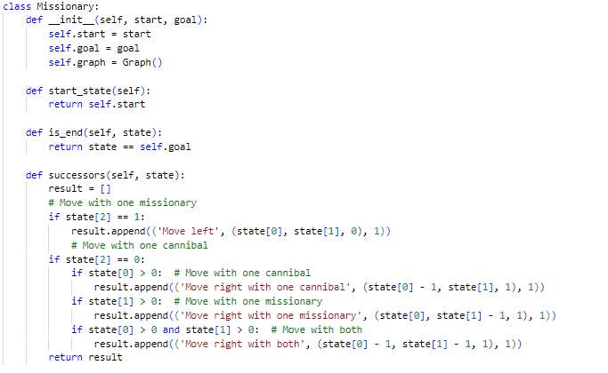

Figure Missionary

## Solution

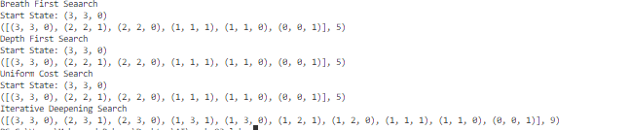

Figure Missionary Solution

# Problem 2

The 8-Puzzle is a sliding puzzle consisting of a 3x3 grid with 8 numbered tiles and one empty space. The goal is to arrange the tiles in numerical order by sliding them into the empty space.

## Code

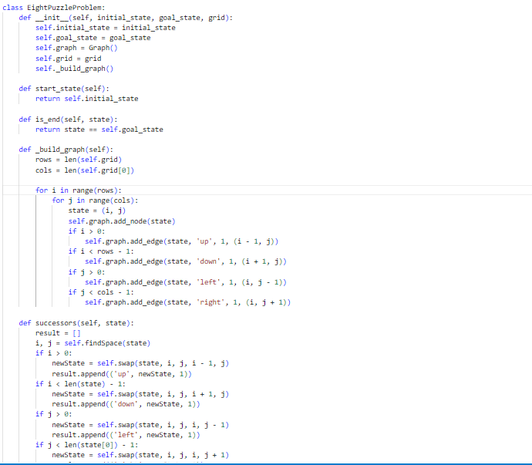

Figure 8 puzzle

## Solution

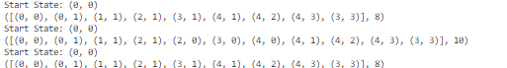

Figure 8 puzzleSolution

# Problem 3

Given a maze represented as a grid, where each cell is either open or blocked, find a path from the start cell to the goal cell.

## Code

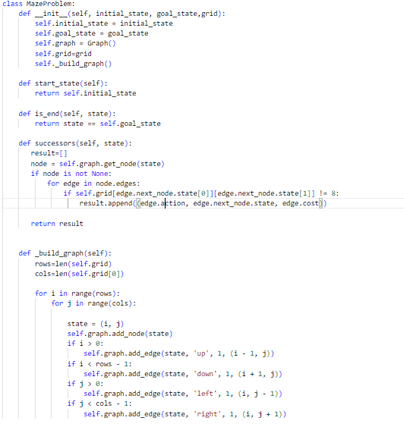

Figure Maze

## Solution



Figure Maze Solution

## Problem 4

You have two jugs with capacities of 4 gallons and 3 gallons, respectively. You need to measure exactly 2 gallons of water using these two jugs.

## Code

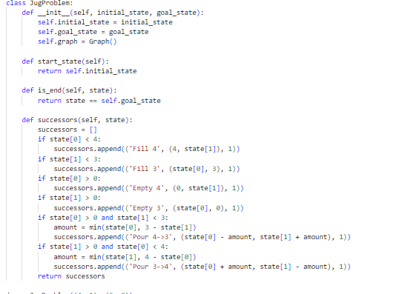

Figure Jug

## Solution

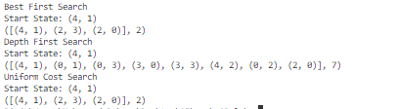

Figure Jug Solution

# Problem 5

A robot is placed in a grid where some cells are obstacles, and it needs to navigate from a start position to a goal position. The robot can move up, down, left, or right but cannot move diagonally or through obstacles.

## Code

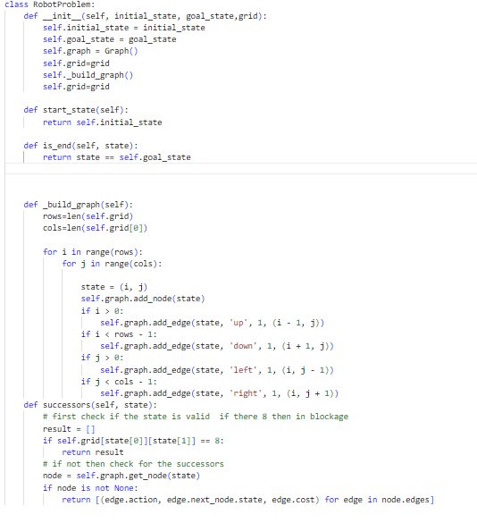

Figure Robot

## Solution

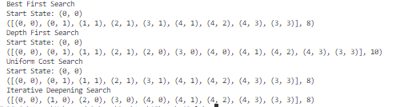

Figure Robot Solution